Objective: - To develop an artificial organic and miniature heart & lung system using stem cells which would reduce the burden on the main heart and lungs and also reduce free radicals.

Aim: - To remove free radicals which are the main culprits which produce various disorders starting from metabolic disorders to malignancies and also cardiac disorders.

Organizations involved in this project: -

ESCI:-

Engineering Staff College of India (ESCI) is an autonomous organ of India's largest body of professional engineers, “The Institution of Engineers (India)”. ESCI was established in the year 1981 with the mandate of providing quality training and education in engineering and techno management fields. Inspired by innovation and governed by excellent council, ESCI strives to offer high quality proficiency development programmes to engineers from industries, R&D labs, academics, public and private organizations. ESCI conducts programmes in core engineering domains, interdisciplinary fields, and customer-specified interdisciplinary areas and also in cutting edge technologies, at its Hyderabad campus and at customers' premises. Experienced faculty of ESCI, ably complemented by the adjunct faculty and external advisors, conduct training programmes in important fields such as additive manufacturing, climate change, engineering analysis and simulation, quality management, renewable energy, remote infrastructure management, smart grids, Human Resource Management including Soft skills and other management field in project & SCM etc. to induce industry-relevant skills among young engineers. Renowned personalities like Late Dr. APJ Abdul Kalam, Shri R. Venkataraman, Mr. Suresh Pachauri, Lt. Gen. (Dr) V.S. Sundaram, Padmashri Prof. R.M. Vasagam and other eminent engineers, academicians and scholars graced the ESCl's Programmes and enriched them. ESCI’s operations are firmly grounded in its desire to act as a bridge between academic institutions, R&D laboratories and organizations in private and public sectors to promote the growth and increased availability of latest know-how and expertise to professional engineers, executives and managers in all these sectors.

Vedala’s Medical Vision Healthcare Services (VMVHS) VMVHS is an organization pertaining to medical fraternity doing and rendering medical services, medical awareness projects, technical help and medical Research along with academics and clinical treatment. VMVHS has services pertaining to medical development, research about medical innovation and inventions and also added are medical services which are being carried out. This organization has been Present since more than a decade and has been conducting research on many medical diseases. Recently been doing research on invention of a Biogenic heart towards improvement for cardiac problems.

VIDEO of Sandesh channel to be inserted. <https://drive.google.com/file/d/1ggmCkJnjsff-MxsLCIwdwUbCwvQksPMS/view?usp=drivesdk> (PLEASE MAKE THE VIDEO AND ADD DIFFERENT SOUND. THE VIDEO SHOULD START FROM 0.00 AND END BY 0.31)

SUBJECT

A miniature heart is created through the bio printing process starting with the patient's own stem cells. Doctors take the cells from the patient via blood sample with aseptic precautions by using growth factor (GF) and also leveraging recent stem cells research inventions. The next step is to reprogram those blood cells which are taken and convert them to create specialized heart cells named Cardiomyocytes from the induced pluripotent stem cells (IPS’c). This is done by a process called as differentiation. Heart tissue grown on spinach leaf wherein researchers turn the vascular system of plants to solve a major bioengineering problem blocking the regeneration of human tissues and organs. The scientists turn to plants culturing beating human heart cells on spinach leaf. In this sequence a spinach leaf is stripped of its plant cells, which is a process called decellularization using a detergent. This process leaves behind the leaf’s vasculature. This looks like a shape of SCAFFOLD.

♣ Ink and Bio printing - The Bio ink is created using specialized heart cells (Cardiomyocytes), combined with nutrients in a liquid environment (hydrogel) along with other materials which help the cells to survive the bio printing process. The Bio ink will then be loaded into a bio printer in a highly specialized 3D Printer designed to protect living cells during 3Dprinting process. This is done by printing one layer at a time, guided by CAD following the specific dimensions obtained from MRI. As the heart cells will not be fused together at this point biocompatible and biodegradable scaffolding will be included. This is done to support the cells and hold them in place.

PROCESS

When the process of procurement of cells is completed the cells will be shifted into a bio reactor which will create the appropriate conditions required for nutrition and oxygen rich environment. The individual cells would begin self-organizing and fusing into networks which will connect to form living healthy tissue. The cells in this tissue will even begin to work in unison and in fact the mass beats.

The Bio-printing process is the stage where a miniature heart is developed using Bioprinter. This heart will remain in the bioreactor until it reaches a desired level of strength and maturity.

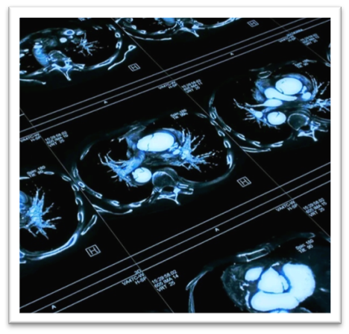

A successful patient deployment would be then possible under aseptic precautions and minimal anesthesia.

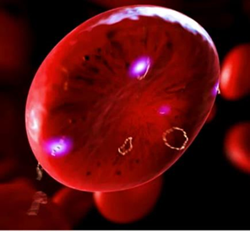

This should be carried out by vascular and CT surgeons, with the help of **adherent glue** ( It is made up of [fibrinogen](https://en.wikipedia.org/wiki/Fibrinogen) (lyophilized pooled human concentrate) and [thrombin](https://en.wikipedia.org/wiki/Thrombin) (bovine, which is reconstituted with calcium chloride)[[1]](https://en.wikipedia.org/wiki/Fibrin_glue#cite_note-pmid8173397-1)that are applied to a site of tissue damage to glue them together.[[1]](https://en.wikipedia.org/wiki/Fibrin_glue#cite_note-pmid8173397-1)

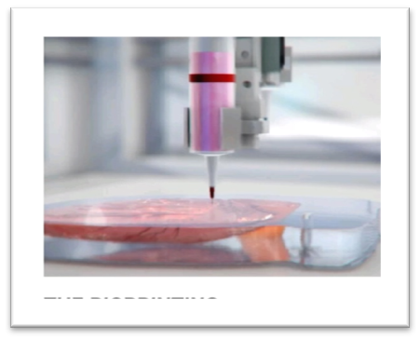

Thrombin is an [enzyme](https://en.wikipedia.org/wiki/Enzyme) and converts fibrinogen into fibrin monomers between 10- and 60-seconds giving rise to a three-dimensional gel). This glue is combination of new heat sensitive gel & glue which will enable blood vessels to be reconnected without puncturing or cutting them with a needle and thread. This is a thermos reversible polymer which is biocompatible. This is named as POLOXAMER 407 which is approved by FDA. Similarly, derma bond, which is a surgical sealant, is also used to attach ends of blood vessels together. This is a novel approach to anastomosis which could play a valuable role in microvascular surgery and beating heart surgery instead of suturing, where there is reconstruction of vessels and anastomosis.

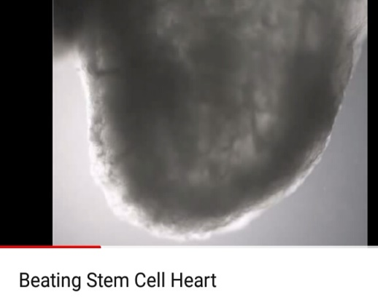

<https://www.youtube.com/watch?v=IxzL5nFOZFw> (START THE VIDEO FROM 0.01 AND END BY 0.21)

Suturing work is not needed at any point, internal or external at the deployment site. The miniature BIOgen BEAT is aptly fit and a perfect genetic match for the patient and is free from risk of rejection, infection or the need for immunosuppressant therapy which is generally used for organ transplant procedure. The patient will then be kept under continuous monitoring for evaluation.

Oxygen consists of 8 electrons (2, 6) and if external electrons have been lost from outer shell then it’s called free radical oxygen. Oxygen electron configuration is 1:2:2p4. Free radicals are molecules with unpaired electrons. They rob other cells of their existing electrons and cause damage wherein oxidative stress occurs when an oxygen molecule splits. Free radicals can cause damage to parts of cells such as proteins, DNA and cell membranes by stealing their electrons through a process called as oxidation.

Free radicals have gained importance due to central role in various physiological conditions and their implication ranges in diverse pathological diseases. These free radicals occur due to exogenous sources like pollution, alcohol, smoking, industrial solvents, pesticides, radiation and drugs like paracetamol and halothane. Free radicals affect various molecules like nuclei acid, mitochondria, lipids and proteins. Thereby by altering the normal redox status leading to increased oxidative stress, the innumerable diseases which affects are Diabetes mellitus, Parkinsonism, Alzheimer’s disease, Multiple sclerosis, Hypertension, Atherosclerosis, Ischemic disease, Asthma, Cataract, Rheumatoid arthritis and various cancers starting from colorectal, breast, prostate and bladder cancers. There is no particular drug which removes the toxicity of free radicals, but it is not clinically and scientifically proved fully. Infact free radicals which we inhale are formed due to all the pollutants present in the atmosphere which damage cell immunity and mitochondria. If we induced the miniature heart made by stem cells at a certain place by reconstructing different vessels with anastomosis which we have molded and have attained after a thorough research which has been in the process. The place where we shall create secondary respiration point, with the help of tissue which is enriched with vessels acts like the lung and also makes pure oxygen without free radicals. Here the last electron from the outer shell is again incorporated to oxygen atom. During this period most of the free radicals maybe eliminated from the body. As this being a prototype, the results which are expected will be shown gradually. The aggregate of enzymatic processes in the tissue respiration are the byproducts of the breakdown of carbohydrates, fats and proteins and subsequently they become oxidized into carbon dioxide, water and also convert into a large amount of energy (ATP). This pure oxygen without free radicals will travel to the right side of the human heart, through the means of major veins. This part is important to know because oxygen is essential element for life and every cell in our body requires its presence for cellular metabolism and the oxygen without free radicals is a boon to every cell of the body. The main point which we have to know here is although there are two variants of blood going on, which are pure blood without free radicals and blood with carbon dioxide (venous blood), oxygen which is present in pure blood without free radicals is a vasoconstrictor whereas blood with carbon dioxide is a vasodilator. During the process of normal blood flow into the right side of major heart from the BIOgen BEAT, it is seen that although there are two variants of blood (blood with oxygen and blood with carbon dioxide), there will not be any fusion of these both as the flow of blood for both is antagonist to each other. We have had succeeded to procure homologous hematopoietic stem cells from the donor by giving GF (growth factors) and also created stem cells in a spinach leaf which acts as a scaffold. Biomedical engineers and scientists will take over the mantle and will create this BIOgen BEAT with the help of 3D printer.

DESCRIPTION OF STEM CELLS

Cells in the body have specific purposes, but stem cells are cells that do not yet have a specific role and can become almost any cell that is required. Stem cells are undifferentiated cells that can turn into specific cells, as the body needs them. Stem cells originate from two main sources: adult body tissues and embryos. Scientists are also working on ways to develop stem cells from other cells, using genetic "reprogramming" techniques.

A person's body contains stem cells throughout their life. The body can use these stem cells whenever it needs them.

Also called tissue-specific or somatic stem cells, adult stem cells exist throughout the body from the time an embryo develops.

The cells are in a non-specific state, but they are more specialized than embryonic stem cells. They remain in this state until the body needs them for a specific purpose, say, as skin or muscle cells.

Day-to-day living means the body is constantly renewing its tissues. In some parts of the body, such as the gut and [bone marrow](https://www.medicalnewstoday.com/articles/285666.php), stem cells regularly divide to produce new body tissues for maintenance and repair.

Stem cells are present inside different types of tissue. Scientists have found stem cells in tissues, including:

* the brain
* bone marrow
* blood and blood vessels
* skeletal muscles
* skin
* the liver

However, stem cells can be difficult to find. They can stay non-dividing and non-specific for years until the body summons them to repair or grow new tissue.

Stem cells are the foundation for all organ and tissue in your body. There are many different types of stem cells which originate from different places in the body. These include embryonic stem cells which exist only at the earliest stages of development and various types of tissue-specific (or adult) stem cells that appear during fetal development and remain in our bodies throughout life.

The types are: -

Embryonic stem cells

Tissue-specific stem cells

Mesenchymal stem cells

Induced pluripotent stem cells

MECHANISM OF BIOgen BEAT

The first thing here which is to be noted is our project is not about an artificial heart. Its a biogenic heart made up of cardiac stem cells with the usage of GMCSF or GCSF or IL3 for procurement of stem cells. Infact these are granulocyte macrophage colony stimulating factors or known as leukine or sargramostim which are used to accelerate the recovery of white blood cells following chemotherapy or before and/ after peripheral blood stem cell transplantation.

Infact we are using mozobil( PLERIXAFOR) injection with combination of GCSF( granulocyte colony stimulating factor which is a glycoprotein which stimulates the bone marrow to produce stem cells) to procure stem cells from the bone marrow to blood stream where the side effects are minimal.

This is done for autologous transplantation.

Mozobil releases hematopoietic stem cells from the bone marrow into the blood stream by disrupting a bond that normally keeps stem cells anchored to the bone marrow. This enables to collect more stem cells during apheresis( blood is filtered to remove the stem cells)

Cellular differentiation is a process where a cell changes from one cell type to another. The blood cells from the sample which is taken will be converted to induce pluripotent stem cells (PSC’s). And in this process may change into cardio myocytes) which is cell differentiation.

These cardio myocytes will then combine with nutrients to turn into a BIOINK.

The next step is 3D printing technology where the BIOINK will be loaded into a bio printer and an appropriate miniature heart of 6 to 10 mm will be printed by using CAD and DICOM.

This process is overlooked by technocrats of 3D printing.

3D printing will be done only after formation of cardio myocytes which are stored under low temperature (minus degrees).

This process will be dealt by experienced pathologists, microbiologists and stem cells professionals where they look after stock cells which are purified by FACS (cell sorting - by usage of primity's fluorescence activated cell sorting).

Then the next step is deployment or transplantation into the patient by expert vascular surgeons and CT surgeons by using latest technology of adhesive method where the vessels are anastomosed, instead of suturing by just applying thermo reversible POLOXAMER 407, which is an adhesive glue or we can also use DERMABOND which is a surgical sealant which is used to attach the ends of blood vessels together.

This miniature heart will create secondary tissue respiration by giving extra electron to free radicals to turn into normal oxygen atom. The exact mechanism is confidential and the vessels used transplantation cannot be revealed as such with due effect of confidentiality clause.

The oxygenated blood without free radicals from the tissues will be passed through major vein which will join into right atrium of the heart.

Many a times a question might arise that whether the pure blood with more OXYGEN which is passing in a vessel along with impure blood in the same vessel may get mixed with each other but Infact the fact behind it is CARBON DIOXIDE which is present in impure blood is most potent vasodilator whereas oxygen is vasoconstrictor. One is vasodilator and another is vasoconstrictor so they won’t allow the other one to get mixed due to policy of constriction and dilation.

The immunological behavior comes in the picture by autologous usage of specialized stem cells.

The miniature heart will be 6 to 10 mm in size and only one heart is required per human.

There is no question of synchronizing with major heart because our concept is entirely different as we are not claiming as a new heart or an artificial heart or any heart which works similar to our major heart.

The concept of our project is genuine and that this is only a preventive possibility and it might be a treatment in the future unless research may hinder the mechanism.

.

Our promise is honest and as mentioned BIOgen BEAT only removes free radicals which may help to reduce disease orientation better than other oral medications like anti-oxidants.

.

This project will not be done on any dogs or pigs because the vessel morphology, anatomy and size differ from human beings (majorly drug clinical trials will be done on pigs and dogs) unless there is production of main heart. BIOgen BEAT concept differs from production of main heart. There is no risk of auto grafting or rejection because autologous production of stem cells and induction is present and rejection will not arise and adverse consequences and immunological problems and reactions will not arise.

.

Coming to clinical applicability day to day research has shown that major disorders are due to pollutants toxins, drugs, CFC's which are the major producers of free radicals which in turn damages cell immunity and mitochondria, ribosomes and DNA which in turn produces maximum disorders ranging from metabolic to oncological.

Our technology is prudent and will see to the maximum towards the light of the day as our framework and readability of the subjective measure along with scientific backing is genuinely correct. Our team comprises of experienced professionals related to clinical pathology, stem cell professionals and microbiologists who knows the subject of cell biology, cell adhesion organogenesis including embryonic development) ECM (extra cellular matrix of bioengineering), interactions and developmental biology including biology of regeneration in a perfect manner. Apart from this we have qualified microvascular surgeons and anatomists and specialists in immunological oncology.

Most importantly we are associated with an institute which comprises of experts in 3D printing.

Mobilization of stem cells in a patient or donor by usage of mozobil with G- CSF will be of minimal side effect.

Though we are optimistic we also know our limitations in research orientation.

Any invention will be only fruitful unless thorough research has to be done.

This research is not only from the stakeholders who are involved in this project but many other professionals are also involved.

Our five domains of this project are: -

procurement of stem cells by using mozobil with G- CSF which will be done under the jurisdiction of reputed clinical pathologist of a corporate hospital under aseptic precautionary measures.

growth of stem cells and evaluation of cardio myocytes under precautionary measures is done by a separate department of stem cells by expertise professionals.

production of miniature heart by using 3D Mapping which is done by professional experts.

Deployment of product into the human being by microvascular surgeons by usage of latest adhesive materials.

assessment of the patient condition and improvement parameters and monitoring of the vitals is done with the help of cardiologists, physicians and other faculty members of all medical specialties and monitoring specialists like intensivists.

Our main project consists and comprises of many departments and staff members.

CONCLUSION: -We are optimistic that our project BIOgen BEAT may at least may reduce the symptoms of diseases alongside 5 to 10 percent which maybe a good sign. At present we cannot assure how much possibility of success ratio will it gain unless research proves it.

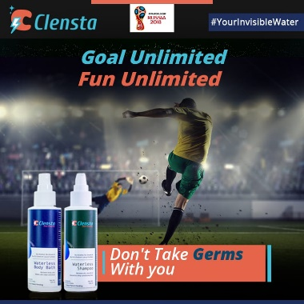Best,

ESCI & VMVHS.

Our sponsors: - This project is sponsored by Sri Manwish traders of CLENSTA. They are also our brand ambassador.

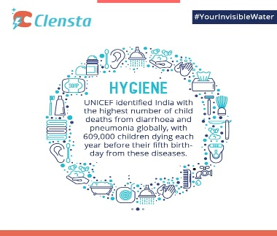

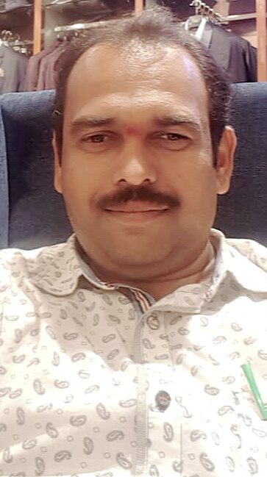

Best Compliments,

Mr. Viswanathan

Mr.Satyam

Vertex Power Systems and Services.

